**Computer**

**Network**

**Class Six**

**Lab 3**

|  |
| --- |
| Lab Objectives:  * Network Topologies * Node |

# Network Topology

Network Topology refers to layout of a network. How different nodes in a network are connected to each other and how they communicate is determined by the network's topology.

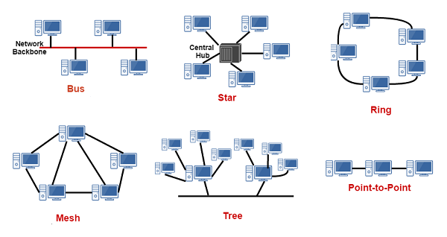

# Bus Topology

## In networking a bus is the central cable. The main wire, that connects all devices on a local-area network ([LAN](https://www.webopedia.com/TERM/L/local_area_network_LAN.html" \t "/home/deepto/Documents\\x/_blank)). It is also called the [backbone](https://www.webopedia.com/TERM/B/backbone.html" \t "/home/deepto/Documents\\x/_blank).

## Bus Topology This is often used to describe the main network connections composing the Internet.  Bus networks are relatively inexpensive and easy to install for small networks. [Ethernet](https://www.webopedia.com/TERM/E/Ethernet.html" \t "/home/deepto/Documents\\x/_blank) systems use a bus topology.

## Main Advantage:  It's easy to connect a computer or device and typically it requires less cable

## IMG_256Main Disadvantage: The entire network shuts down if there is a break in the main wire and it can be difficult to identify the problem if the network shuts down.

# Ring Topology

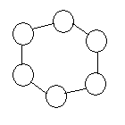

## A local-area network ([LAN](https://www.webopedia.com/TERM/L/local_area_network_LAN.html" \t "/home/deepto/Documents\\x/_blank)) whose topology is a ring.

## That is, all of the nodes are connected in a closed loop. Messages travel around the ring, with each node reading those messages addressed to it.

## Main Advantage: One main advantage to a ring network is that it can span larger distances than other types of networks, such as bus networks, because each node regenerates messages as they pass through it.

## **Main Disadvantage:** In a ring network, one malfunctioning node affects the rest of the network.

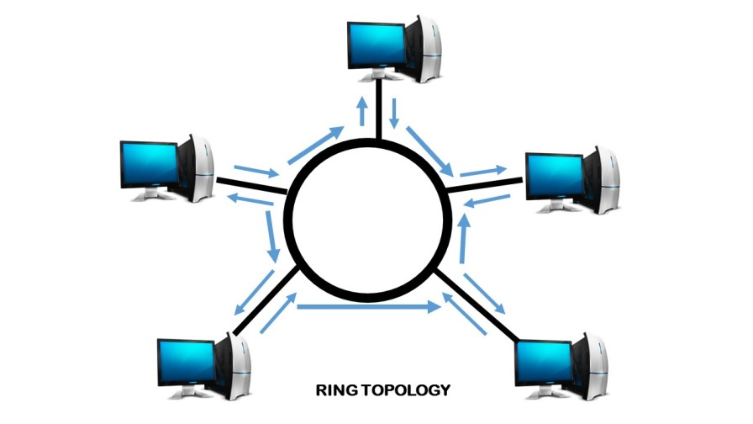

# Star Topology

## In a star network devices are connected to a central computer, called a hub. Nodes communicate across the network by passing data through the hub.

## IMG_256

## 

## **Main Advantage:** In a star network, one malfunctioning node doesn't affect the rest of the network. **Main Disadvantage:** If the central computer fails, the entire network becomes unusable.

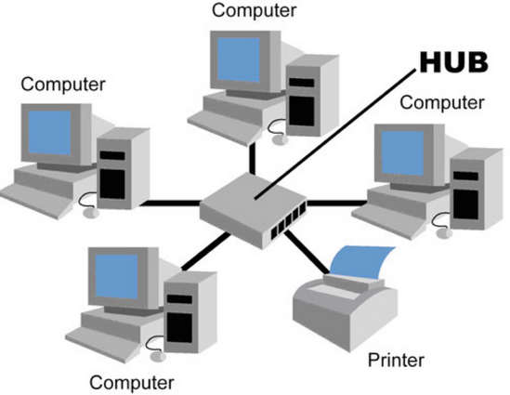

# MESH Topology

## In a mesh network, devices are connected with many redundant interconnections between network nodes.

## In a true mesh topology every node has a connection to every other node in the network. There are two types of mesh topologies:

## Full mesh topology

## Partial mesh topology

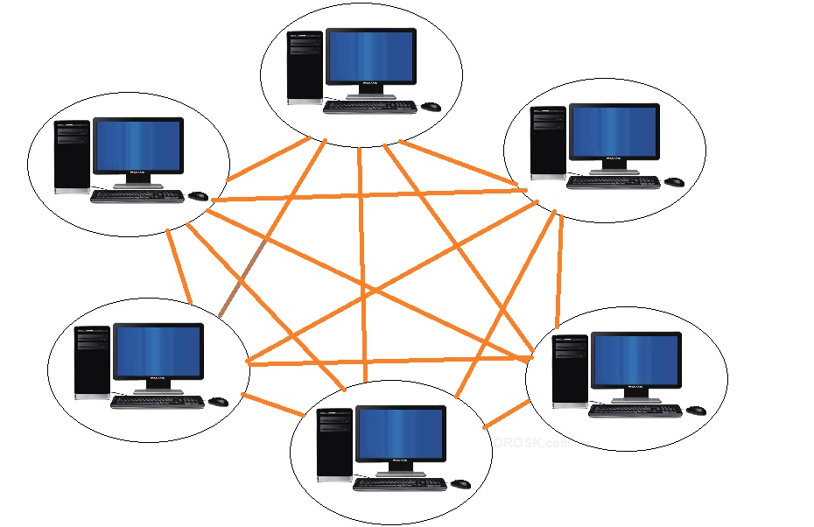

## Main Advantage: Manages high amounts of traffic, because multiple devices can transmit data simultaneously.

## Main Disadvantage: The cost to implement is higher than other network topologies

# Tree Topology

## This is a "hybrid" topology that combines characteristics of linear bus and star topologies.

## In a tree network, groups of star-configured networks are connected to a linear bus backbone cable.

## IMG_256

## **Main Advantage:** A Tree topology is a good choice for large computer networks as the tree topology "divides" the whole network into parts that are more easily manageable.

## **Main Disadvantage:** The entire network depends on a central hub and a failure of the central hub can cripple the whole network.